Chapter 3 Learning Activity: Do puppy pictures improve struggling relationships?
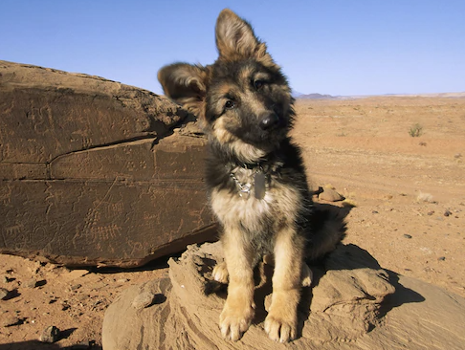

1. Read this article from National Geographic (a copy of the pdf can be found in Module 3 under Content on ecourseware) for a description of McNulty’s study. Then answer the questions in this exercise. I have included some screenshots of the article to help you answer some of the questions.
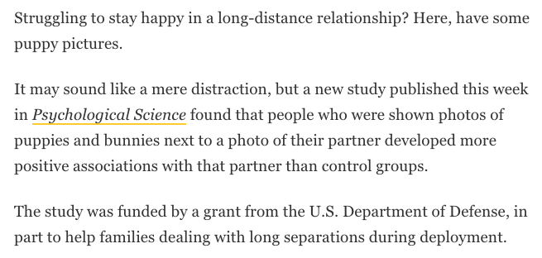
- What causal claim does the researcher seem to make in this study? (Be sure to use a causal verb!)
Photos of puppies and bunnies placed next to a partner’s photo caused people to develop positive associations with the partner or improved struggling relationships.

- What are the two variables in the causal claim you listed in (a)? Identify whether each variable is manipulated or measured.
People’s feelings towards their partners --measured
Photos of puppies and bunnies --manipulated

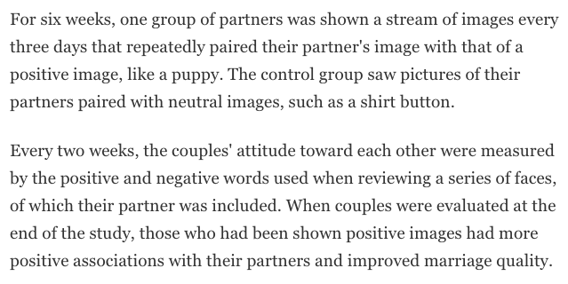
- What kind of study did the researchers originally do—a correlational study or an experimental study? How do you know?
Correlational study, the study was geared towards identification of variables and looking for the relationship between them.

b) Sketch a well-labeled graph of the “positive evaluation of partner” result they describe. (Hint: There are two groups, so you should make a bar graph.) To create your graph click on the blue box below and then click “edit”. Make sure to label the axes of your graph. If you need more help, view my tutorial on using google docs under the Welcome module under Content on ecourseware.
Those Shown puppy pics
Control group
Attitude
Towards
partner

- Do the result and the study design support the causal claim that “pairing puppy and bunny photos with photos of long-distance romantic partners cause people to rate their partners higher”? Apply, each of the three causal criteria to this situation:
Yes, the causal claim is supported

Name of causal criterion: | Application/interpretation to this example:
Covariance | The photos of puppies and bunnies covaried with the attitude of partners towards one another beyond what was reasonably expected by chance
Temporal precedence | The photos of bunnies preceded the partners’ attitudes temporarily
Internal validity | The attitude-puppies photos relationship was only explained by the photos of bunnies and puppies and not by any other causes.

